Test Case: tc006_SPX_Dev5_Crear_Requisicion_Spot_Tipo_Cobro_Proyect_Urgent
Step 1 - Enter username and password and click to button Enter: Credentials Entered
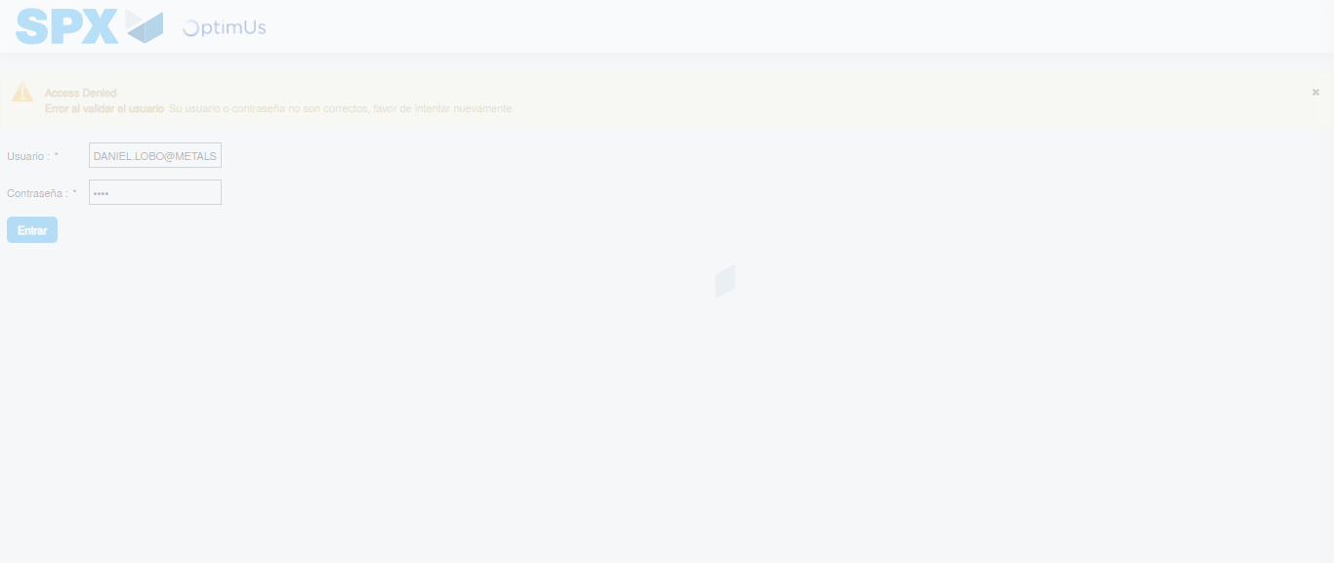Image file-name: QC_Testing-tc006_SPX_Dev5_Crear_Requisicion_Spot_Tipo_Cobro_Proyect_Urgent-1784215426407

Step 2 - Select to UEN and Access to Spot Buy Requisitions : UEN Correctly selected and Correct access
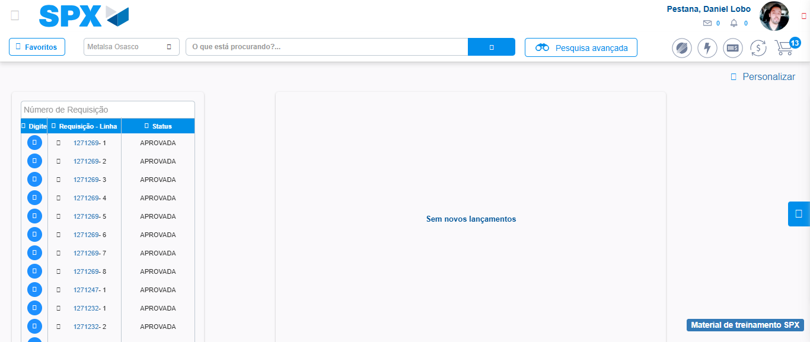Image file-name: QC_Testing-tc006_SPX_Dev5_Crear_Requisicion_Spot_Tipo_Cobro_Proyect_Urgent-1784215466162

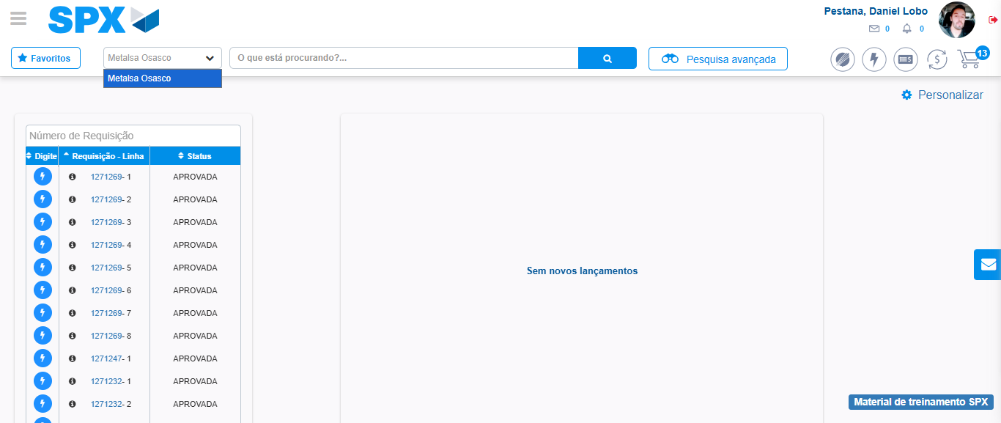Image file-name: QC_Testing-tc006_SPX_Dev5_Crear_Requisicion_Spot_Tipo_Cobro_Proyect_Urgent-1784215468831

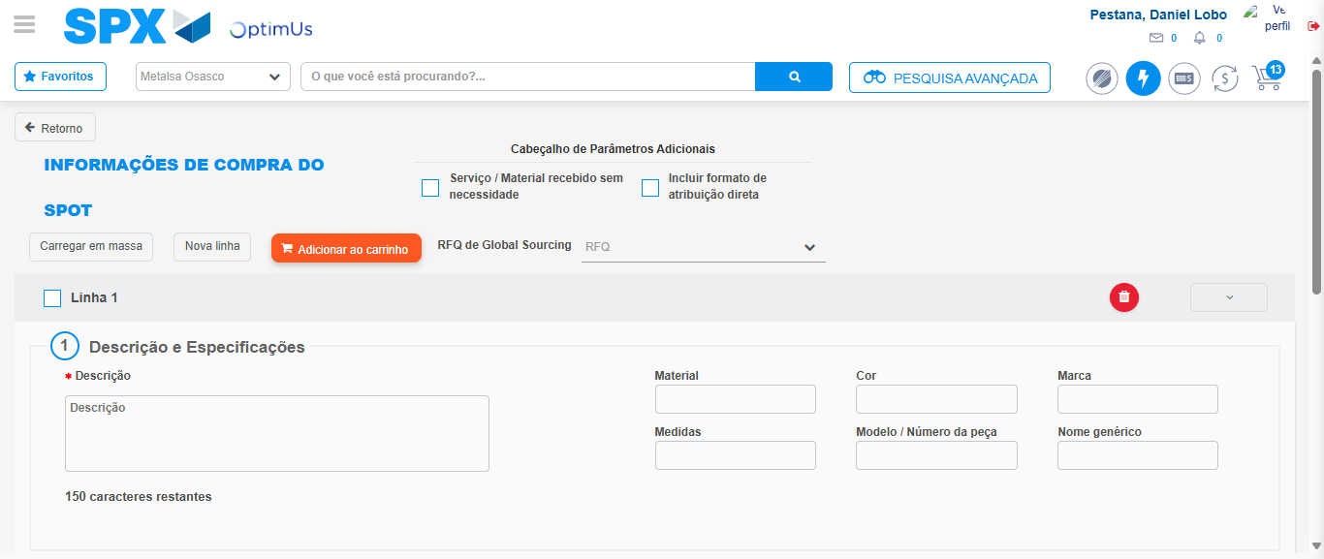Image file-name: QC_Testing-tc006_SPX_Dev5_Crear_Requisicion_Spot_Tipo_Cobro_Proyect_Urgent-1784215477603

Step 3 - Data Capture Spot Buy Requisition: Data captured correctly
Image file-name: QC_Testing-tc006_SPX_Dev5_Crear_Requisicion_Spot_Tipo_Cobro_Proyect_Urgent-1784215477899

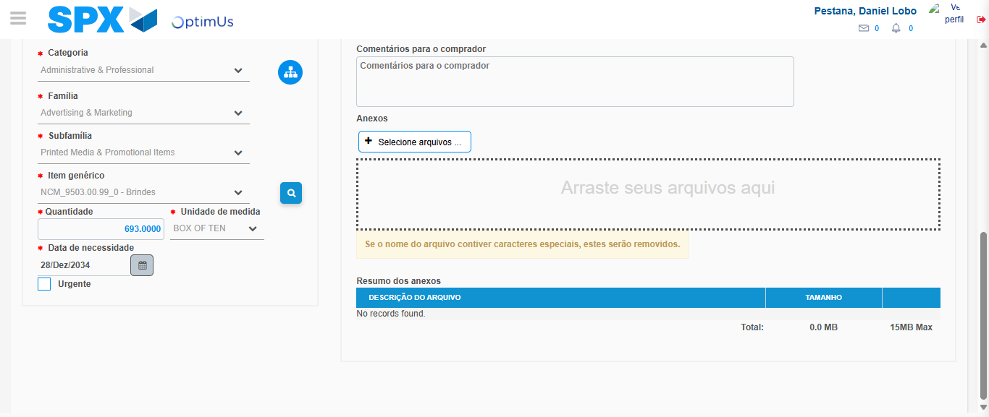Image file-name: QC_Testing-tc006_SPX_Dev5_Crear_Requisicion_Spot_Tipo_Cobro_Proyect_Urgent-1784215492018

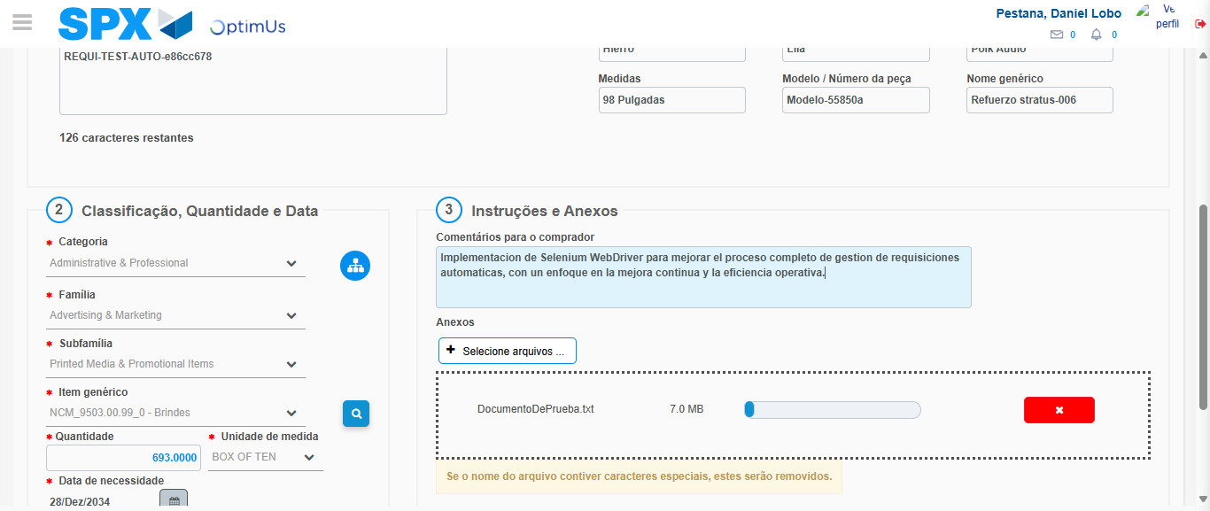Image file-name: QC_Testing-tc006_SPX_Dev5_Crear_Requisicion_Spot_Tipo_Cobro_Proyect_Urgent-1784215493098

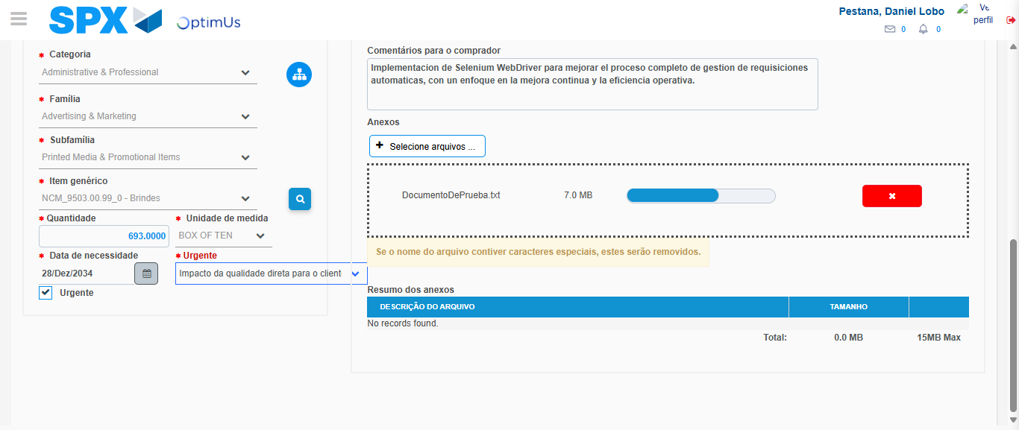Image file-name: QC_Testing-tc006_SPX_Dev5_Crear_Requisicion_Spot_Tipo_Cobro_Proyect_Urgent-1784215496939

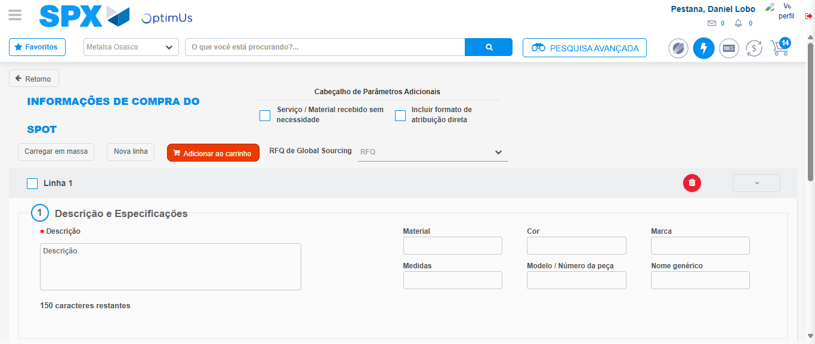Image file-name: QC_Testing-tc006_SPX_Dev5_Crear_Requisicion_Spot_Tipo_Cobro_Proyect_Urgent-1784215503780

Step 7 - Return to Main Page SPX : Return to Main Page SPX
Image file-name: QC_Testing-tc006_SPX_Dev5_Crear_Requisicion_Spot_Tipo_Cobro_Proyect_Urgent-1784215466162

Image file-name: QC_Testing-tc006_SPX_Dev5_Crear_Requisicion_Spot_Tipo_Cobro_Proyect_Urgent-1784215468831

Image file-name: QC_Testing-tc006_SPX_Dev5_Crear_Requisicion_Spot_Tipo_Cobro_Proyect_Urgent-1784215477603

Image file-name: QC_Testing-tc006_SPX_Dev5_Crear_Requisicion_Spot_Tipo_Cobro_Proyect_Urgent-1784215506057

Image file-name: QC_Testing-tc006_SPX_Dev5_Crear_Requisicion_Spot_Tipo_Cobro_Proyect_Urgent-1784215506230

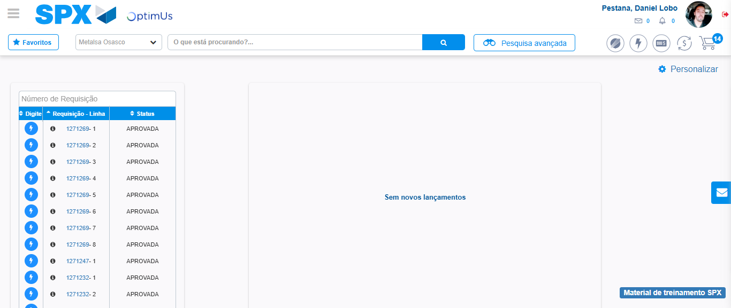Image file-name: QC_Testing-tc006_SPX_Dev5_Crear_Requisicion_Spot_Tipo_Cobro_Proyect_Urgent-1784215527387

Step 8 - Log Out : Log Out SPX
Image file-name: QC_Testing-tc006_SPX_Dev5_Crear_Requisicion_Spot_Tipo_Cobro_Proyect_Urgent-1784215527559

